Agriculture Branch, Government of Yukon
Lot 4 Murray Agriculture Subdivision – Cattle in the Boreal Forest/Arctic Ground Squirrel project
March 2023-Dec 2024

Introduction
Silvopasture is an ancient practice that integrates trees and pasture into a single system for raising livestock. Pastures with trees sequester five to 10 times as much carbon as those of the same size that are treeless while maintaining or increasing productivity and providing a suite of additional benefits. Livestock continue to emit the greenhouse gases methane and nitrous oxide, but these are more than offset by carbon sequestration, at least until soil carbon saturation is achieved.
Silvopasture also offers financial benefits for farmers and ranchers. Livestock, trees, and other forest products, such as nuts, fuelwood, fruit, and mushrooms, generate income on different time horizons and help protect farmers from risk. The health and productivity of both animals and the land improve. *Project Drawdown, Climate Solutions, Silvopasture, https://drawdown.org/solutions/table-of-solutions
Silvopasture may be created by planting previously cleared lands with trees, or by thinning existing forest to permit more light to reach the forest floor. Thinning, combined with grazing encourages the growth of grasses which then form meadows amongst tree cover. Thinning the forest, removing flammable understorey shrub growth, and maintaining it thinned also reduces wildfire fuel availability.
Forest thinning is often undertaken by land clearing or forestry machinery. Timber may or may not be salvaged and brash is usually burnt. The machinery used for thinning releases greenhouse gases (GHG) as does the burning of brash.
The project has two aims:
- To discover if livestock can be used to create a silvopasture from existing Yukon forest, in this case predominantly aspen woodland with some willow and spruce. This is to demonstrate (and understand the issues with) minimizing machinery use, growing meat whilst clearing, utilising brash, understanding regrowth, how to deal with fallen trunks and stumps, and size of fallen and standing trunks
- To investigate if creating silvopasture from forest encourages utilisation of the area by the arctic ground squirrel (Urocitellus parryii). Arctic ground squirrels are an important protein source in Indigenous diets. Thus, does developing woodland or forest into silvopasture increase conventional (livestock), and Indigenous (arctic ground squirrel) protein production?
Materials and Methods
To the west of Whitehorse in the Ibex Valley, Murray Agriculture Subdivision, Lot 4 consisted of 64 ha of uncleared mixed, but mainly deciduous (aspen) forest. The lot was divided into 4 x 16 ha sections.
The 16ha section to the south-west, adjacent to the highway was chosen for the project and termed Section 1. This was fenced with 5 strands of barb wire, with a top and bottom smooth wire placed at the heights required for wildlife friendly fencing. This contains livestock but permits wildlife to pass through.
Section 1 is adjacent to Lot 3, owned by Horse Haven Ranch.
Section 1 contained primarily aspen, with some willow, and a smaller number of spruce with an understory of grasses, forbs, and shrubs.
2021
In September 2021, Agriculture Branch staff completed a forage assessment of Lot 4 for grasses.
2022
In summer 2022, staff of the Department of Environment, Yukon Government undertook a survey for arctic ground squirrel presence across Lot 4.
2023
Horse Haven Ranch was contracted to provide the livestock, and livestock management for the project. Livestock were admitted to the area through a gate from Lot 3 as follows:
March 10 – May 3:
36 horses, which were removed on May 3. For this period, the gate remained open, allowing the horses to move between Lot 3 and the woodland of Section 1.
May 4 – Sept 29:
23 cows, 19 calves, and 1 bull: 43 cattle in total were moved to Section 1. The gate was closed and the cattle maintained on Section 1. A water tank and trough was set up, and supplementary feeding of hay undertaken as required.
November 4th through to May 2024:
36 horses allowed access through the open gate from Lot 3.

2024
Forty Cattle reintroduced in June 2024 but removed within 6 weeks. A highly maneuverable Bobcat “mini-mulcher” was employed in October to remove the majority of the downed trees.

Results and observations
Arctic Ground Squirrel survey:
There appeared to have been some use of the area by arctic ground squirrels in the distant past but no recent activity was apparent.
Forage Survey:
The September 2021 average forage value for Section 1 was 16g of dry weight grass forage per square meter.
Soil sampling and photographic record:
Section 1 was visited by Agriculture Branch staff six times over the 2023 season to take soil samples for chemical and microbial analysis and photograph the effects of the livestock on the woodland
In 2023 soil samples were sent to Element Labs in Calgary for chemical analysis; for microbial analysis the samples were sent to Agriculture and Agri-Food Canada (AAFC) Harrow Research and Development Centre.
In 2024 soil sampling visits occurred twice on May 23 and Oct 16. Samples were sent to Natural Resources Analytical Laboratory (NRAL), University of Alberta for chemical analysis, and to AAFC Harrow for microbial analysis
Microbial analysis is underway at time of writing.
Greenhouse gas (GHG) sampling:
The site, and an adjacent control site was sampled for GHG (CO2, N2O) release form the soil on 11th and 26th June, 11th July, 22 August and 16th October. This involved three sampling chambers per site, sampled 4 times over an approximately 30-40 minute period.

Criteria of interest:
 | Section 1, Horse and cattle Area |  |  |  |  |  | Control
 | NO3-N ppm | PO4-P ppm | K ppm | % Organic matter | Soil temperature 'C |  | NO3-N ppm | PO4-P ppm | K ppm | % Organic matter | Soil temperature 'C
Date
Spring 2023 (June 14) | 0 | 18 | 169 | 5.7
Fall 2023 (Nov 2) | 0 | 56 | 276 | 10 |  |  | 0 | 9 | 153 | 7.3
2023 average (6 samples) | 1 | 31 | 229 | 6 |  |  | 0 | 14 | 178 | 6
Spring 2024 (May 23) | 0.4 | 31.9 | 239.1 | 7.51 | 5.85 |  | 1.3 | 23.2 | 163.9 | 6.76 | 3.13
Fall 2024 (Oct 16) | 0.53 | 37.31 | 204.4 | 10.62 | 1 |  | 0.48 | 7.32 | 163 | 7.81 | 2

In the first season, changes are apparent in the cattle area. The trampling of the forest floor has reduced soil insulation, such that the soils warms up faster than the control soils in the spring, and cool faster in fall. The spring cattle area soil temperatures were similar to those found in cultivated fields nearby on the same day.
Soil chemistry may take longer to show signs of change, however K has increased in the cattle area and remains 20% higher than at the start of the project, and similarly above the control. P also appears elevated compared to the start, and control. Organic matter has also increased in the cattle area compared to the start of the project and the control.

Horses 2023 and 2024:
Horses used the woodland for shelter during the winter months. Their effect on breaking trunks and branches (i.e. clearing) was observed to be minimal and unintentional. It appears horses utilized the woodlands in winter for shelter during difficult weather only and reciprocated by adding nutrients to the soil through deposition of faeces and urine.
Cattle 2023:
Feeding and watering:
Supplementary hay was provided to the woodland cattle at a rate of 2/3 of what the cattle would normally be provided by the plants of grassland pasture over July – September. The woodland provided 1/3 of their feed requirements during this period. An equivalent group of cattle on pastured grass received no supplementary feeding during this period
No other feed inputs were made by the farmer to the cattle in woodland area.
Cattle preferentially ate the natural browse. Observation showed 1-3 cattle working at a tree to bend or break it over whilst other cattle watched. Once the tree was down they moved in to consume the foliage and younger shoot growth. Trees were brought down on purpose to reach the foliage. It was apparent the fresh leafy material was preferred over the supplementary hay.
The foliage not only has a different nutritional composition to dried grass (hay), it contains significantly more water. Although not a Yukon study, Tew* noted Aspen foliage nutrition varies from Spring to Fall as follows: protein 10.1-20.9%; Fat 6.3 – 12.3%; water 59-74%. The water content is significant as hay in round bales has an optimum moisture content of 15% **. The extra water in foliage is important for lactating cows as they need additional water and this green feed provides them water as they eat. Green feed also reduces the demand for water from the water tank, reducing the amount of staff time required to refill the tank.
*Tew, Ronald K. Seasonal Variation in the Nutrient Content of Aspen Foliage. Apr. 1970, https://doi.org/10.2307/3799040.
**https://www.alberta.ca/bale-moisture

Silvopasture creation:
Quantifying the area opened up through the downing of trunks was not objectively quantified in 2023. Aerial photography via drone was attempted, but software to recognize the change between the start and end of the cattle period was not available.
Four subjectively chosen 10m x 10m quadrats were investigated to count the number of trunks downed, those remaining standing, and the diameters of each group.
51% of the trunks in the 4 quadrats were downed; all downed trunks measured were under merchantable size (10cm diameter at chest height). Trunks left standing were a mix of merchantable and undersize.
The majority of trunks downed were aspen, some willow was uprooted but in general the cattle did not destroy willow. They may have browsed the leaves, but the trunk survey was undertaken after leaf fall.
The downed trunks remained in situ.

2024:
Livestock
36 Horses used the area for shelter during inclement weather over the winter until early May 2024.
There was a delay re-introducing the cattle due to farm operational reasons and they were moved back into Section 1 on 24th June. It soon became apparent the cattle were having difficulty maneuvering amongst the downed trees.
Compared to 2023 they spent the majority of their time near the supplementary feeding station, and did not roam often into undamaged areas with remaining up-right trees. Cattle that ventured into the areas of pushed down trees to forage on regrowth sustained foot and leg damage from the splintered and tangled tree trunks. The cattle foraging/tree clearing part of the project was terminated in late July after a bull had to be euthanized after gorging itself on a split tree trunk and all the cattle were removed from Section 1.
In terms of vegetation removal, the cattle had downed many trees in 2023 but they had not flattened them to the ground. The broken and splintered trunks remained in many cases angled upwards, and had dried and hardened over winter and spring. When the cattle attempted to push through, these “stakes” or “spears” would catch on the skin and cause punctures and scrapes. The understorey of shrubs, grasses and forbs was grazed, and effectively trampled into the soil.
Machinery use:
Fall soil sampling was undertaken in October. Subsequently a bobcat mounted forestry mulching head was used to mulch the downed trees but leave those standing intact. The bobcat was small and maneuverable enough to work within the remaining standing trees, and the head powerful enough to work through the fallen trees, reducing them to mulch. Twenty-four hours of machinery use mulched the majority of the fallen trees that had become such a dangerous obstacle to further cattle pasturing.
The bobcat burnt 240 litres of diesel during this process; 1 litre of diesel produces 2.7kg of GHG, thus the mulching operation released 648kg of GHG.
Mulching was chosen as a responsible land clearing alternative to piling and burning the downed trees. Whilst we cannot quantify the amount of wood the cattle knocked down, we do know on average a hectare of Yukon woodland contains 200t of wood, burning the wood from one ha releases 240-400t of GHG. This project encompassed 16ha. The mulching operation released GHG to the equivalent of burning 16-27m2 of forest.
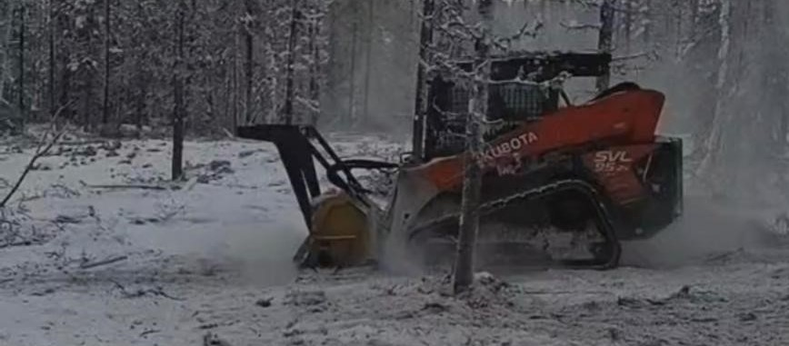

Conclusions:
- Pasturing cattle in a northern boreal predominantly deciduous forest is an effective pre-clearing technique; further work is required to evaluate the effectiveness in a predominantly coniferous forest.
- Cattle effectively push down trees of under 10cm diameter (“non-merchantable”) at chest height
- Cattle eat leaves, shoots, shrubs, forbs, grasses and other undergrowth
- Cattle trample inedible undergrowth, the organic duff layer, and their wastes into the surface soils, quickly leading to a decrease in soil insulation, and increases in soil P, K, and organic matter.
- This trampling also reduces the availability of fuels for wildfire.
- Cattle do not flatten the downed trees, and these become a hazard to cattle as they dry and harden. They also remain available as wildfire fuel.
- Mulching machinery quickly and effectively converts this hazard to livestock into a surface mulch, opening up the area and further reduces wildfire fuel availability.
- Machinery use and cost is considerably reduced compared to not using cattle as a pre-clearing treatment.
- The area is now available for further development into a silvopasture or for extraction of merchantable timber prior to further development into a crop field.
- Future study will monitor site vegetation, soil development, GHG release, and whether arctic ground squirrels began to utilise the area.

Jonathan Lucas, Agriculture Lands Manager, Dec 2024
Appendix, photo record of project
Control, the Forest pre-cattle
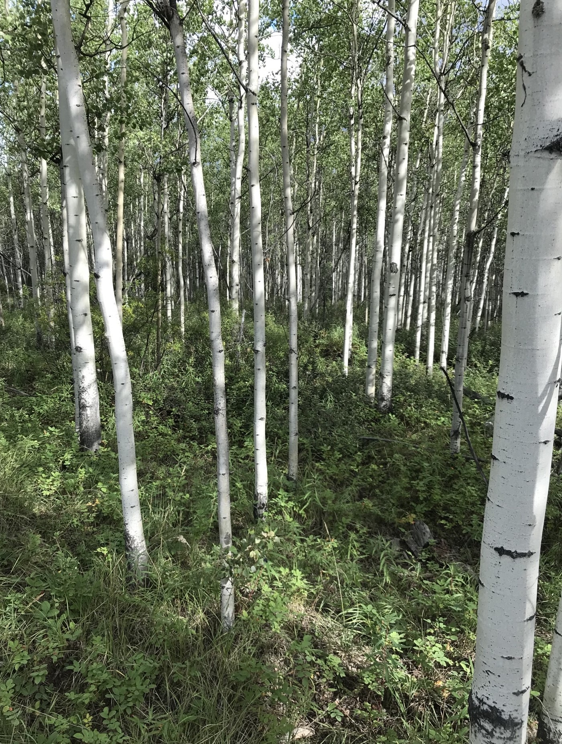
June 14 2023, Bull in forest
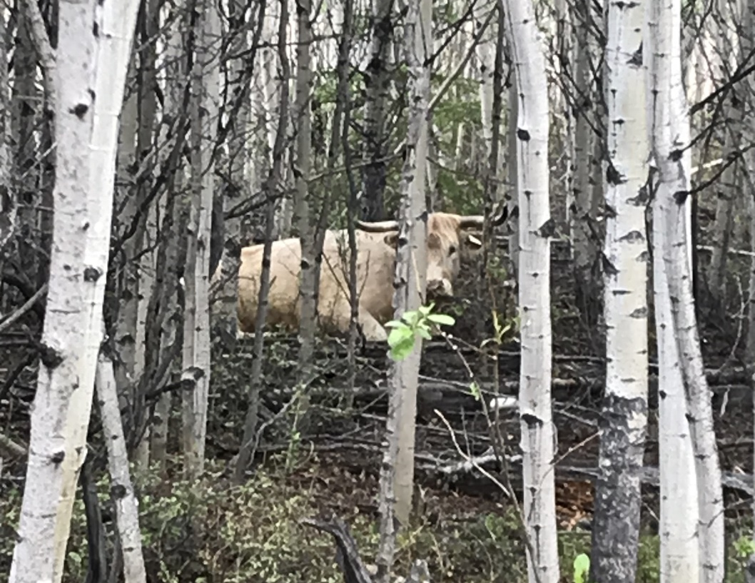
Jun 14 2023, early damage
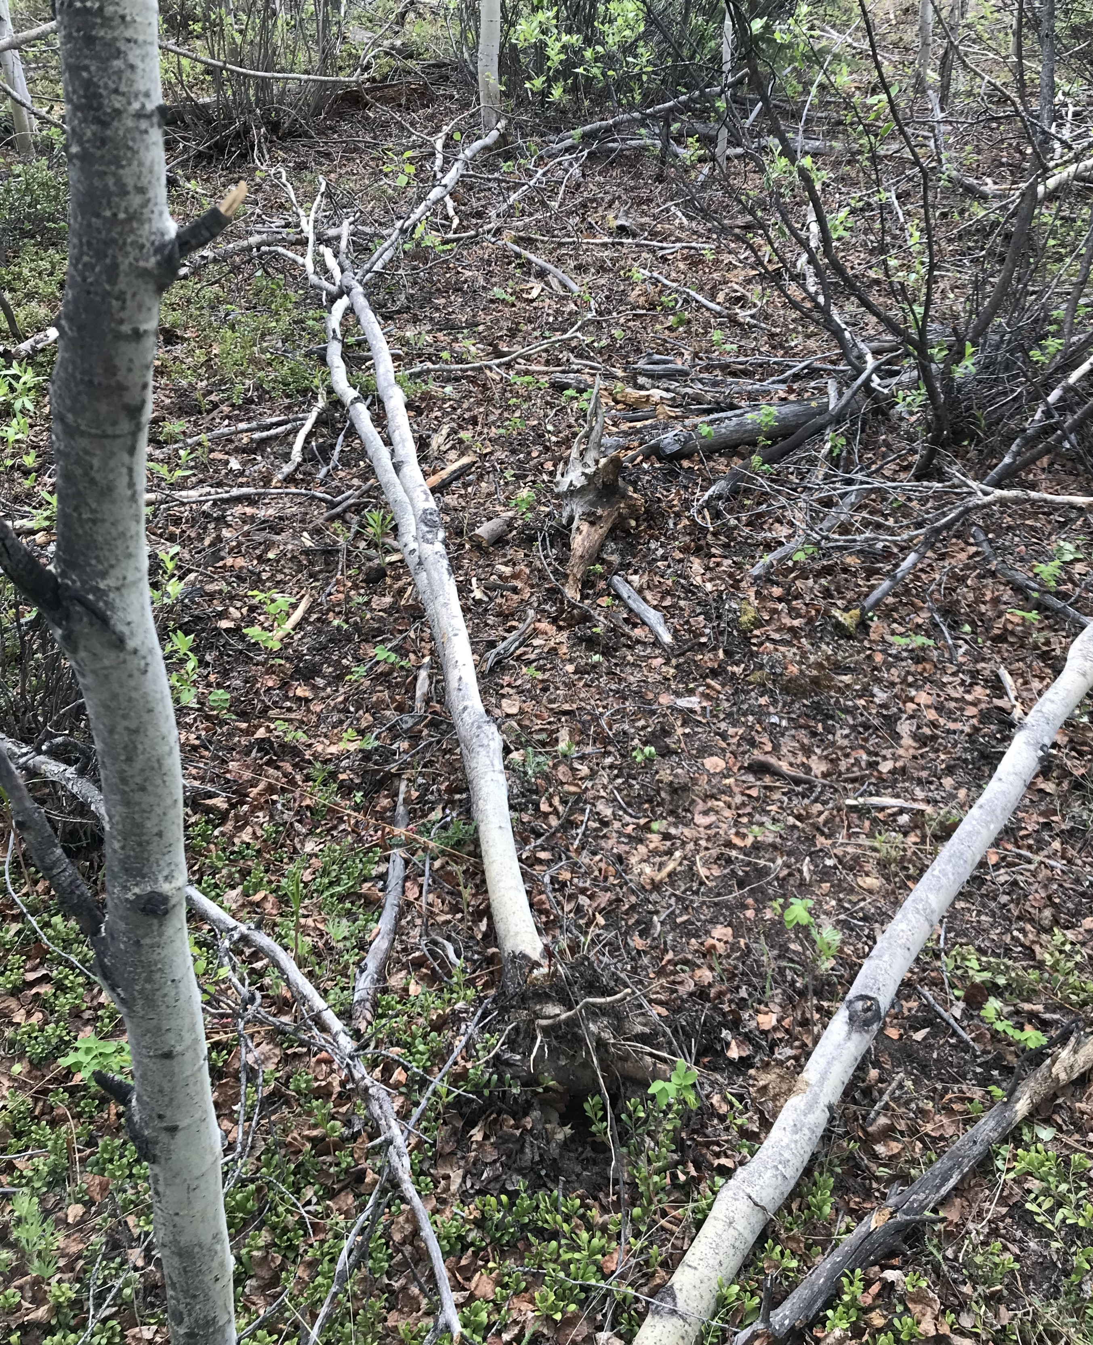

Aug 30th 2023, the cattle have been at work
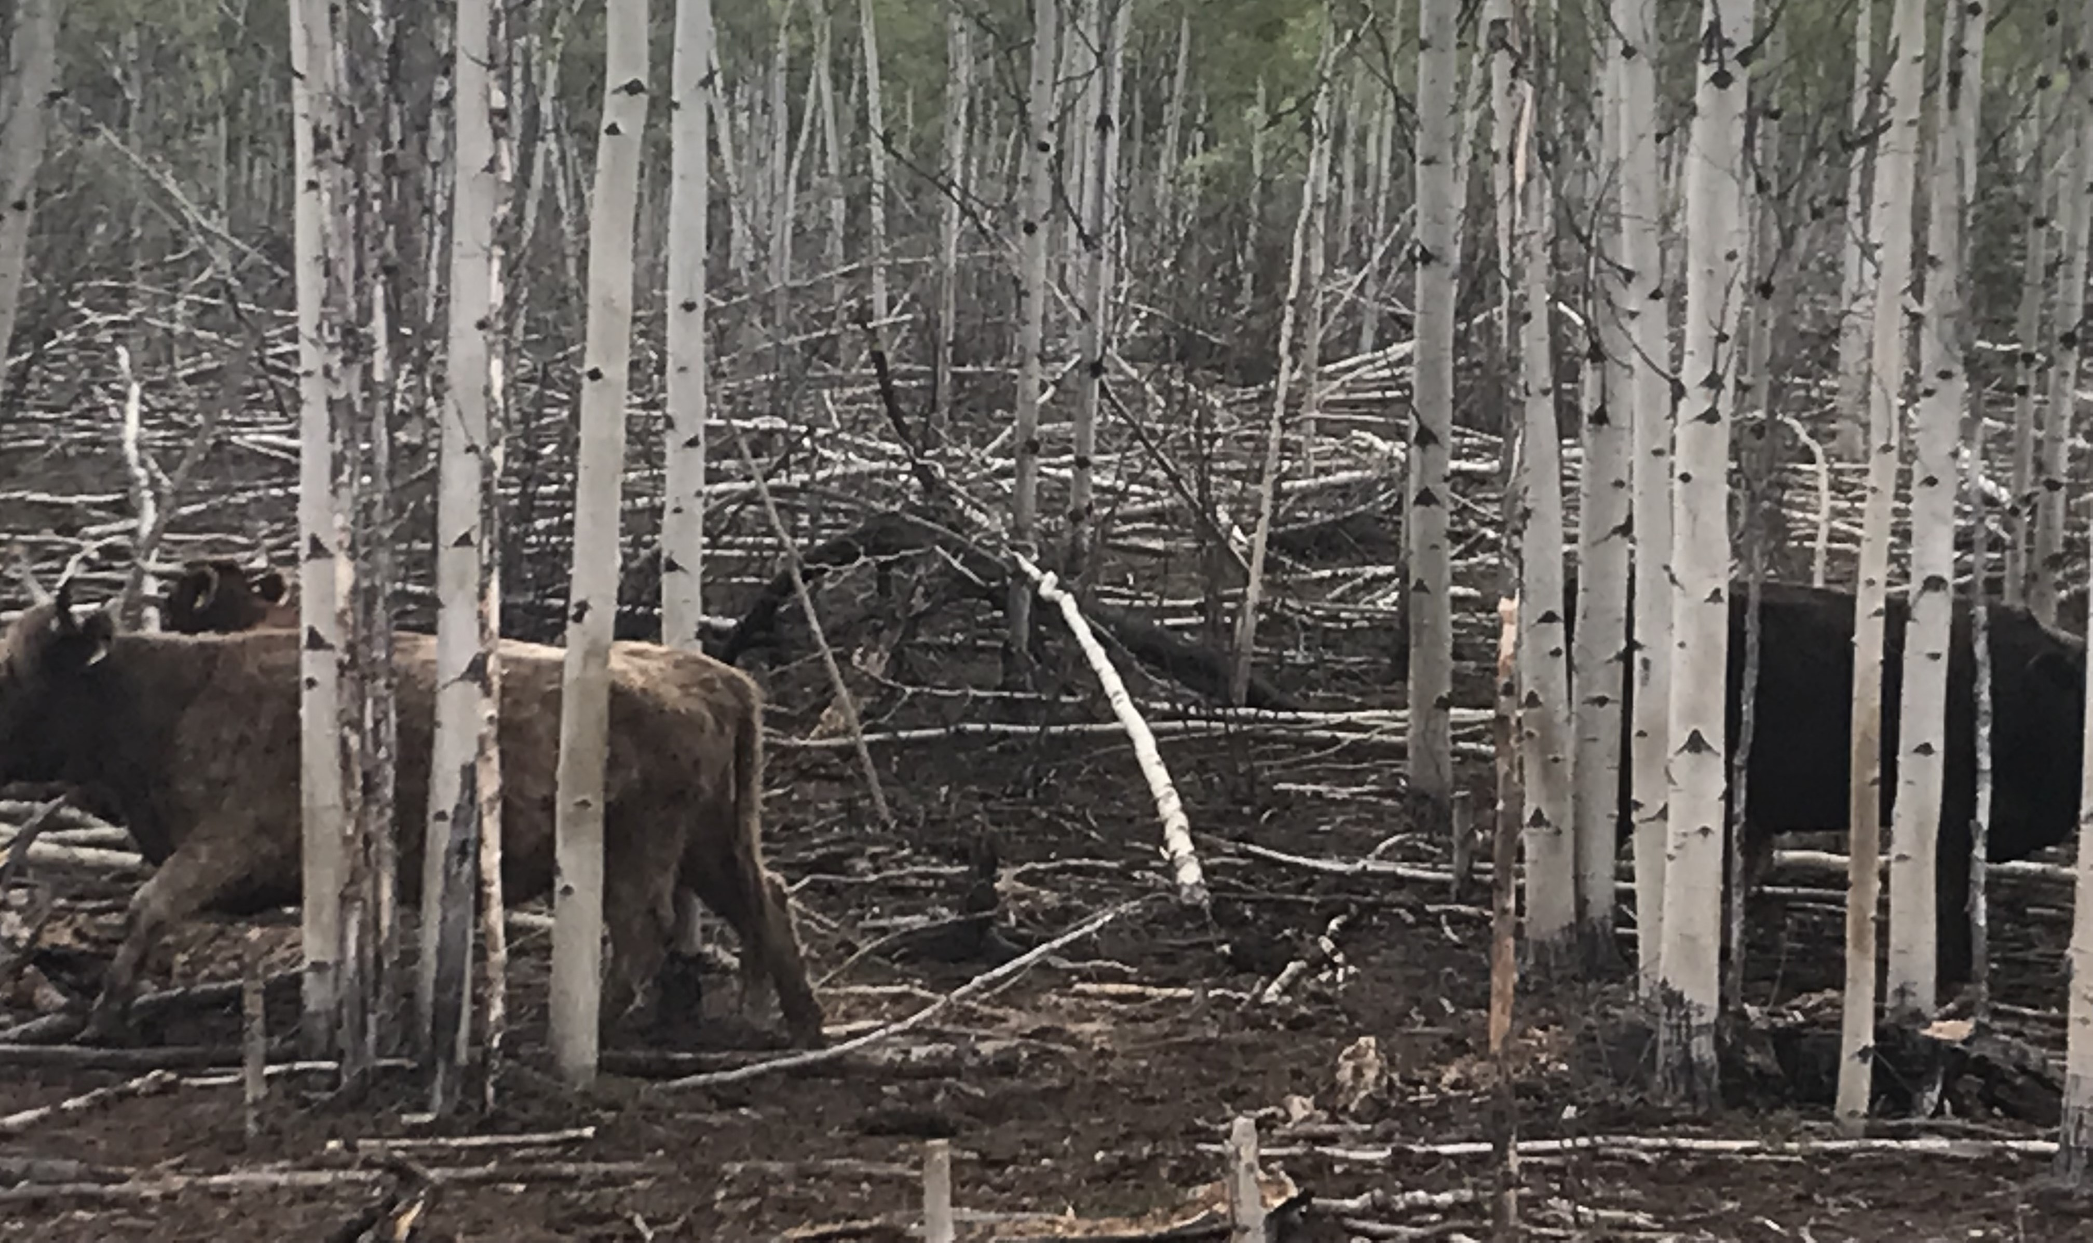

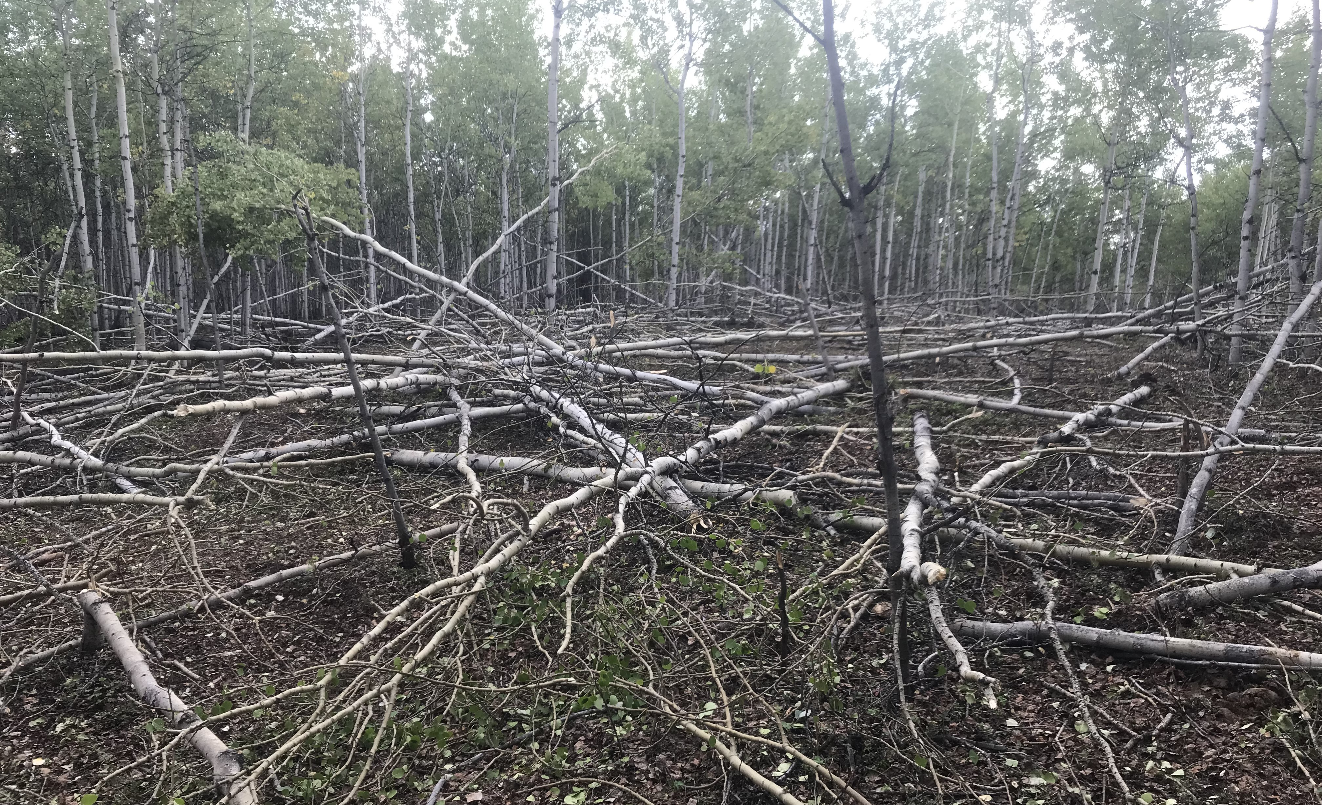

Oct 16, 2024, cumulative Cattle Damage
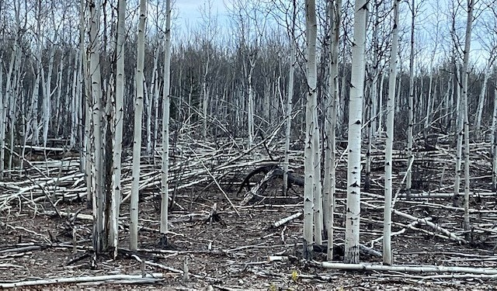
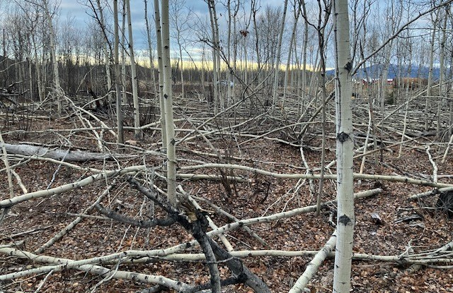

Post Mulching, Oct 21 2024
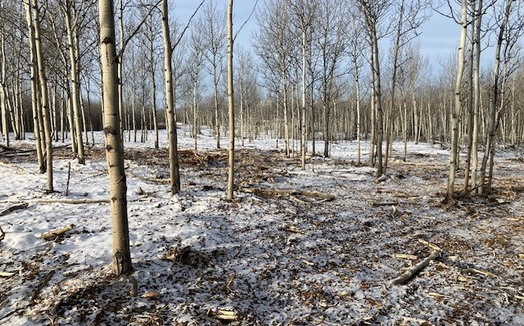
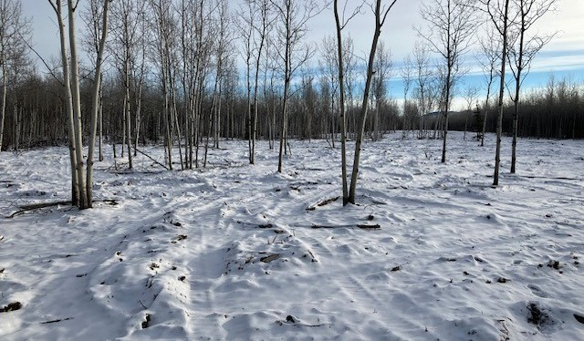
Acknowledgments
Thank you for the participation of Horse Haven Ranch in this project, and to the staff of Agriculture Branch, Shannon Gladwin, Matt Larsen, Erin McBryan, and Meg Mackay.

